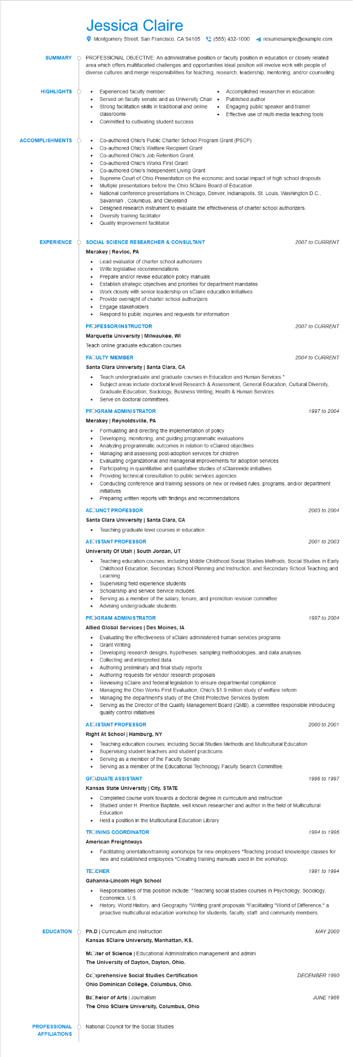
SUMMARY
Jessica Claire
Montgomery Street, San Francisco, CA 94105 (555) 432-1000
resumesample@example.com
PROFESSIONAL OBJECTIVE: An administrative position or faculty position in education or closely related area which offers multifaceted challenges and opportunities Ideal position will involve work with people of diverse cultures and merge responsibilities for teaching, research, leadership, mentoring, and/or counseling
Experienced faculty member
Served on faculty senate and as University Chair
•
Strong facilitation skills in traditional and online classrooms
•
Accomplished researcher in education Published author
Engaging public speaker and trainer Effective use of multi-media teaching tools
HIGHLIGHTS
•
ACCOMPLISHMENTS
EXPERIENCE
. Committed to cultivating student success
Co-authored Ohio's Public Charter School Program Grant (PSCP)
Co-authored Ohio's Welfare Recipient Grant
Co-authored Ohio's Job Retention Grant,
• Co-authored Ohio's Works First Grant
.
•
•
Co-authored Ohio's Independent Living Grant
Supreme Court of Ohio Presentation on the economic and social impact of high school dropouts Multiple presentations before the Ohio SClaire Board of Education
National conference presentations in Chicago, Denver, Indianapolis, St. Louis, Washington D.C., Savannah, Columbus, and Cleveland
Designed research instrument to evaluate the effectiveness of charter school authorizers. Diversity training facilitator
Quality Improvement facilitator
SOCIAL SCIENCE RESEARCHER & CONSULTANT
Merakey | Revloc, PA
Lead evaluator of charter school authorizers
•
Write legislative recommendations
Prepare and/or revise education policy manuals
Establish strategic objectives and priorities for department mandates
Work closely with senior leadership on sClaire education initiatives
Provide oversight of charter school authorizers
• Engage stakeholders
Respond to public inquiries and requests for information
PROFESSOR/INSTRUCTOR
Marquette University | Milwaukee, WI
Teach online graduate education courses
FAOULTY MEMBER
Santa Clara University | Santa Clara, CA
2007 to CURRENT
2007 to CURRENT
2004 to CURRENT
• Teach undergraduate and graduate courses in Education and Human Services *
• Subject areas include doctoral level Research & Assessment, General Education, Cultural Diversity, Graduate Education, Sociology, Business Writing, Health & Human Services.
Serve on doctoral committees.
PROGRAM ADMINISTRATOR
Merakey | Reynoldsville, PA
• Formulating and directing the implementation of policy
•
Developing, monitoring, and guiding programmatic evaluations
·
Analyzing programmatic outcomes in relation to sClaired objectives
Managing and assessing post-adoption services for children
•
Evaluating organizational and managerial improvements for adoption services Participating in quantitative and qualitative studies of sClairewide initiatives
Providing technical consultation to public services agencies
1997 to 2004
Conducting conference and training sessions on new or revised rules, programs, and/or department initiatives
• Preparing written reports with findings and recommendations
ACOUNCT PROFESSOR
Santa Clara University | Santa Clara, CA
2003 to 2004
• Teaching graduate level courses in education
ASOISTANT PROFESSOR
University Of Utah | South Jordan, UT
2001 to 2003
Teaching education courses, including Middle Childhood Social Studies Methods, Social Studies in Early Childhood Education, Secondary School Planning and Instruction, and Secondary School Teaching and Learning
Supervising field experience students
Scholarship and service Service includes:
Serving as a member of the salary, tenure, and promotion revision committee
Advising undergraduate students.
PROGRAM ADMINISTRATOR
Allied Global Services | Des Moines, IA
Evaluating the effectiveness of sClaire administered human services programs
•
Grant Writing
Developing research designs, hypotheses, sampling methodologies, and data analyses Collecting and interpreted data
•
Authoring preliminary and final study reports
•
Authoring requests for vendor research proposals
Reviewing sClaire and federal legislation to ensure departmental compliance
Managing the Ohio Works First Evaluation, Ohio's $1.9 million study of welfare reform
•
Managing the department's study of the Child Protective Services System
1997 to 2004
• Serving as the Director of the Quality Management Board (QMB), a committee responsible introducing quality control initiatives
ASOISTANT PROFESSOR
2000 to 2001
Right At School | Hamburg, NY
•
Teaching education courses, including Social Studies Methods and Multicultural Education
•
Supervising student teachers and student practicums
· Serving as a member of the Faculty Senate
Serving as a member of the Educational Technology Faculty Search Committee.
GRADUATE ASSISTANT
1996 to 1997
Kansas State University | City, STATE
Completed course work towards a doctoral degree in curriculum and instruction Studied under H. Prentice Baptiste, well known researcher and author in the field of Multicultural Education
•
Held a position in the Multicultural Education Library
TROINING COORDINATOR
1994 to 1996
American Freightways
• Facilitating orientation/training workshops for new employees *Teaching product knowledge classes for new and established employees *Creating training manuals used in the workshop.
TECCHER
Gahanna-Lincoln High School
1991 to 1994
Responsibilities of this position include: *Teaching social studies courses in Psychology, Sociology, Economics, U.S.
History, World History, and Geography *Writing grant proposals *Facilitating "World of Difference," a proactive multicultural education workshop for students, faculty, staff, and community members.
EDUCATION
Ph.D | Curriculum and Instruction
Kansas SClaire University, Manhattan, KS.
MOOter of Science | Educational Administration management and admini
The University of Dayton, Dayton, Ohio.
CcOprehensive Social Studies Certification
Ohio Dominican College, Columbus, Ohio.
Bachelor of Arts | Journalism
The Ohio SClaire University, Columbus, Ohio
PROFESSIONAL O National Council for the Social Studies AFFILIATIONS
MAY 2000
DECEMBER 1990
JUNE 1986

